EXPERIMENT 12.B

Aim:To implement FTP
Date: 30-03-20

The Program
1. FTPClient
#include <stdio.h>
#include <string.h>
#include <errno.h>
#include <sys/socket.h>
#include<netinet/in.h>
#include<time.h>
#define PORT_FTP 21 /* FTP connection port */
#define SERVER_ADDR "192.168.1.6" /* localhost */
#define MAXBUF 1024

int main()
{ int sockfd;
struct sockaddr_in dest;
char buffer[MAXBUF];

/*---Open socket for streaming---*/
if ( (sockfd = socket(AF_INET, SOCK_STREAM, 0)) < 0 )
{
perror("Socket");
exit(errno);
}

/*---Initialize server address/port struct---*/
bzero(&dest, sizeof(dest));
dest.sin_family = AF_INET;
dest.sin_port = htons(PORT_FTP);
if ( inet_aton(SERVER_ADDR, &dest.sin_addr.s_addr) == 0 )
{
perror(SERVER_ADDR);
exit(errno);
}

/*---Connect to server---*/
if ( connect(sockfd, (struct sockaddr*)&dest, sizeof(dest)) != 0 )
{
perror("Connect ");
exit(errno);
}

/*---Get "Hello?"---*/
bzero(buffer, MAXBUF);
recv(sockfd, buffer, sizeof(buffer), 0);
printf("%s", buffer);

/*---Clean up---*/
close(sockfd);
return 0;
}

Screenshot

1.WebServer
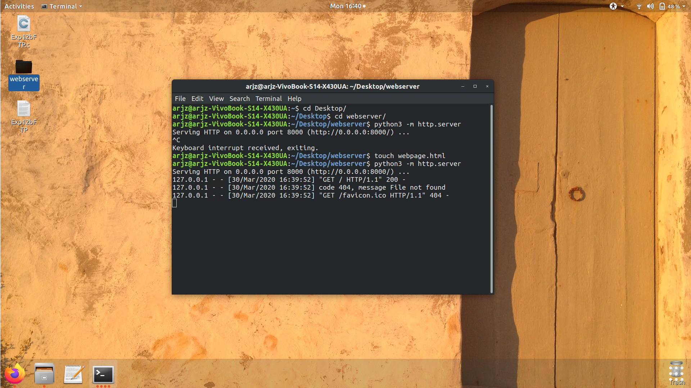
2.Browser
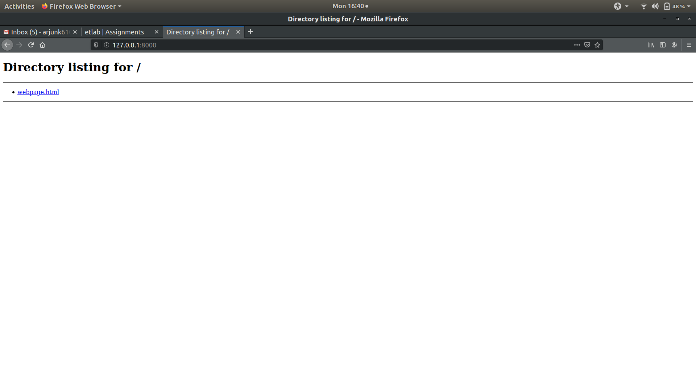
3. Directory
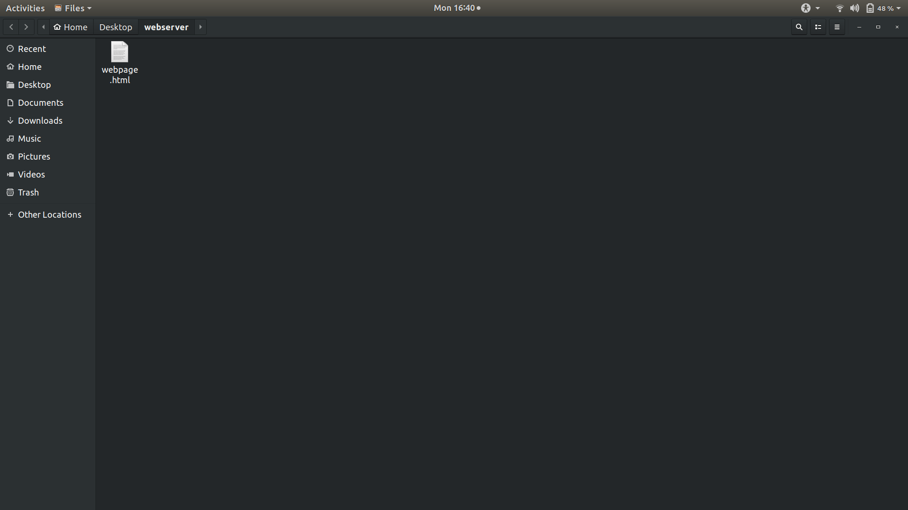
Output File

1.WebServer
python3 -m http.server
Serving HTTP on 0.0.0.0 port 8000 (http://0.0.0.0:8000) . . .
127.0.0.1 - - [30/Mar/2020 16:39:52] “GET / HTTP/ 1.1” 200 -
127.0.0.1 - - [30/Mar/2020 16:39:52] code 404, message File not found
127.0.0.1 - - [30/Mar/2020 16:39:52] “GET favicon.ico HTTP1.1” 404 -

2.FileServer
ftp <ip address>
eg: ip 192.168.43.57
Connected to 192.168.43.57
220 (vsFTPd 3.0.3)

3.FtpClient
./ftpclient
220 (vsFTPd 3.0.3)

